**Laboratory 5**

**Arduino IDE Code**

The Arduino uses an ultrasonic sensor to measure distances by emitting sound waves and timing their echoes. It continuously checks the measured distance against a 5 cm threshold, triggering a buzzer alarm if the object is too close. The measured distance is sent over wiFi to an MQTT broker, which acts as a communication channel between the Arduino and other systems.

**FlowFuse**

FlowFuse processes the distance data received from the MQTT broker and applies logic to determine if the threshold is met. A function node formats the data into messages like "Alarm: 5cm threshold reached. Distance: X cm" for conditions under the threshold, or "Distance measured: X cm" for normal readings. Throttling techniques prevent excessive notifications, ensuring data is forwarded more slowly to the dashboard. At the same time the dashboard is showing real time payload, in this case the distance.

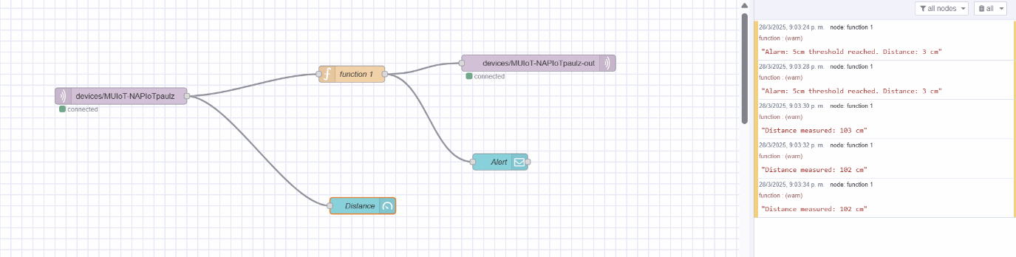

**Dashboard 2.0**

The dashboard provides a user-friendly interface to visualize the distance data in real-time. A gauge displays the distance in centimeters, while notifications pop up with alert messages like "Alarm: 5cm threshold reached. Distance: X cm" whenever the threshold is breached. This allows users to monitor the sensor readings and take action when needed.

